**Alteryx Sample - Learning Activity - API and Macro**

**Introduction**

The Learning Activity report relies on data from several vendors. One of these, O’Reilly, has introduced a new API for data retrieval. Alteryx was used to call the API and transform the data into a data source file for Tableau reporting.

**Alteryx Workflow Summary**

|  |  |
| --- | --- |
| **Workflow** | **Description** |
| O'Reilly - Get Historical Usage Data.yxmd | Uses configurable input parameters of Start Date and End Date to generate a detailed list of learning activity for each date |
| O'Reilly - Macro - Get Usage Timeline by Set of Dates.yxmc | Macro element of the Get Historical Usage workflow. Calls API once for an input date |
| O'Reilly - Aggregate Units Viewed and Last Access Date.yxmd | Starting with file containing the historical learning data, this workflow aggregates the total time spent and latest access by person and course |

**Workflow: O'Reilly - Get Historical Usage Data**

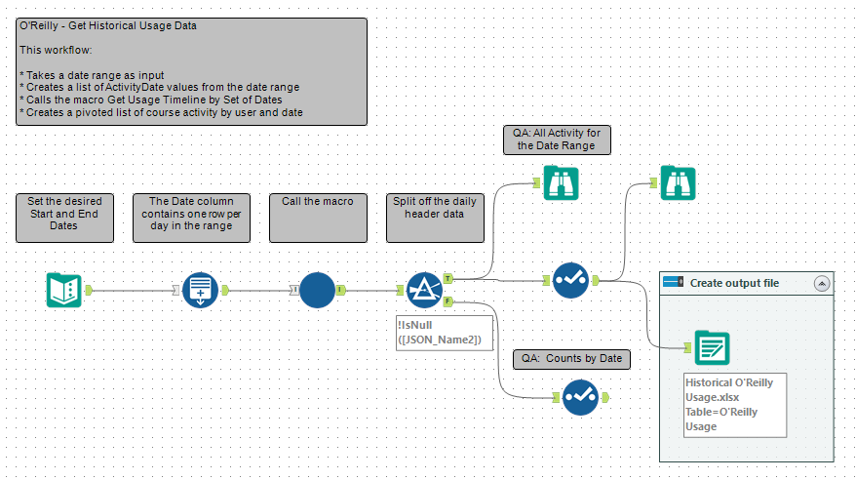

**Workflow: O'Reilly - Macro - Get Usage Timeline by Set of Dates**

This is the workflow module represented by the blue circle macro in the workflow above

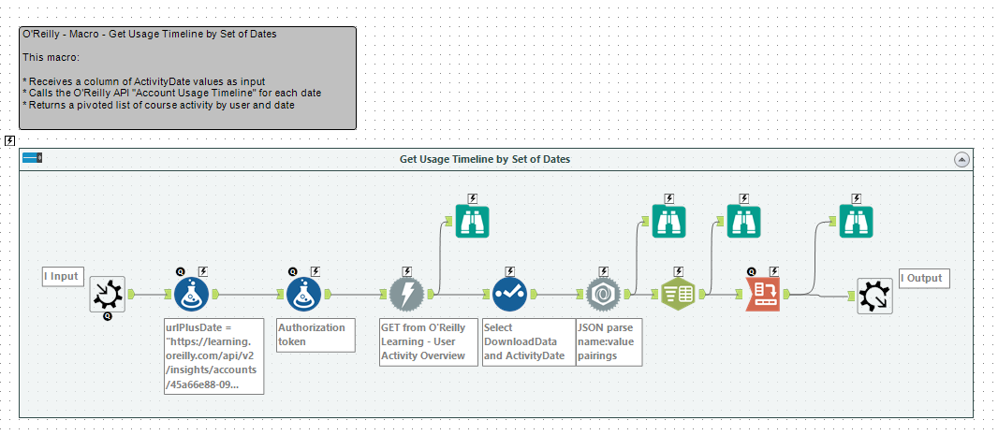

**Workflow: O'Reilly - Aggregate Units Viewed and Last Access Date**

